PSEUDO CODE

BEGIN

INPUT n;  
 INPUT a1, a2, a3, … an;  
 max = a1;  
 i = 1;  
 IF(i<n)

WHILE  
If (i>=n)

Break;  
 IF(ai>MAX)

MAX=ai;  
 i++;

End while;

Display max;

END

________________________________________

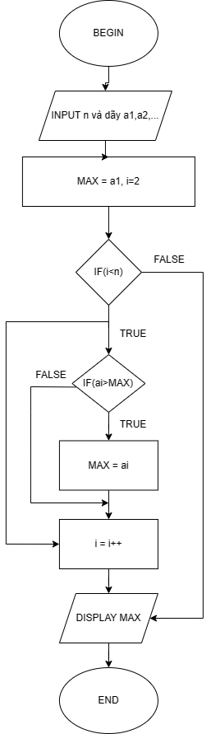FLOWCHART